*Stakeholder Analysis*

For the system we have proposed, the stakeholders we have identified are lawyers and law firms.

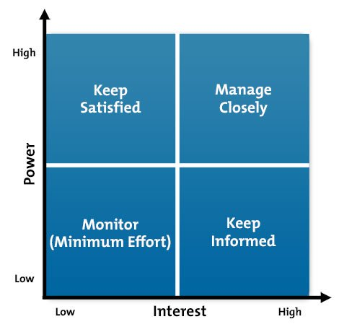

* **High power, highly interested people (Manage Closely)**: you must fully engage these people, and make the greatest efforts to satisfy them.
* **High power, less interested people (Keep Satisfied)**: put enough work in with these people to keep them satisfied, but not so much that they become bored with your message.
* **Low power, highly interested people (Keep Informed)**: adequately inform these people, and talk to them to ensure that no major issues are arising. People in this category can often be very helpful with the detail of your project.
* **Low power, less interested people (Monitor)**: again, monitor these people, but don’t bore them with excessive communication.

What the stakeholders would expect from this system?

* Delivery of accurate verdicts based on the collected keywords.
* Produce result set of matching court cases accurately and with minimum time.
* Delivery of accurate probabilities of winning a court case (based on previous cases that have taken the same nature as the unsettled one).
* Prevent clients from being unjustly convicted of a crime.
* Prevent bribery and corruption from influencing the law.
* Amend the cases of those who have been delivered an unjust sentence (if a verdict should have been delivered at all).